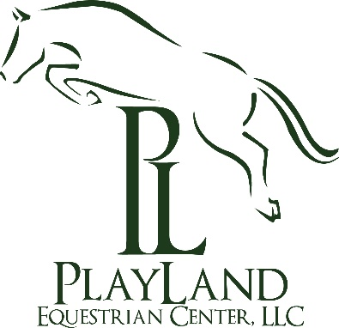
Playland Equestrian Center, LLC,
Glenda Player, Manager
12924 Molasses Road, Union Bridge, MD 21791
(301)-788-1188
glendaplayer@gmail.com

STALLION SERVICE CONTRACT FOR TRANSPORTED COOLED FRESH SEMEN

This agreement, made and entered into on ______________, is between Playland Equestrian Center, LLC “Stallion Owner” and __________________, hereafter known as “Mare Owner”. If mare is leased, a copy of the lease agreement is required. This document verifies that Playland Equestrian Center, LLC agrees to furnish transported, cooled fresh semen to breed the mare:
Mare Name: __________________________ Registration Number: _____________________________
Date of Birth: ____________________ Color:___________________ Markings:____________________
To the stallion: PL Diamond Hill
Mare Owner Veterinarian: _______________________________________________________________
Address: ______________________________________________ Telephone: _____________________

- The fee is $1,000.00, with a booking deposit of $250.00. The deposit amount shall be paid at the time of booking.
- The mare owner will also be responsible for the cost of the semen collection, handling, and shipping canister (or the cost of a disposable container). All associated costs with collection and breeding will be through _________________________________________________________.
- The remainder of the payment of $750.00 is due at Playland Equestrian Center, LLC at the time of collection. Please make check payable to Playland Equestrian Center, LLC.
- Mare owner should contact Playland Equestrian Center, LLC when mare foals.
- Any attempt to obtain a pregnancy with the transported, cooled semen in any mare other than the one described in this contract is prohibited without written approval from Playland Equestrian Center, LLC.

- The mare owner shall agree to have said mare examined by a licensed veterinarian and inoculated as necessary.
- The mare owner shall agree to keep are in good physical conditions throughout the pregnancy, vaccinated as advised by your veterinarian and dewormed regularly or shall return privileges and stud fees are forfeited.
- Should the mare abort or the foal fail to stand and nurse, it is the responsibility of the mare owner to inform Playland Equestrian Center, LLC in writing attested to by a licensed veterinarian within 10 days of the event. In either case, Playland Equestrian Center, LLC agrees to re-breed the mare as soon as she is fit only if PL Diamond Hill is still owned by Playland Equestrian Center, LLC as a stallion. A handling fee of all associated collection and transportation costs are payable to Playland Equestrian Center, LLC and collection agency of Playland Equestrian Center’s choice in the event of re-breeding.
- If, after breeding through three heat cycles the mare fails to conceive, Playland Equestrian Center, LLC offers the following options:
    - The mare owner may ship the mare to Playland Equestrian Center, LLC for artificial insemination in the same or next breeding season. The mare owner is responsible for transportation cost and arrangements. The mare owner is responsible for board, vet, farrier, etc., and a $400 handling fee for re-breeding.
    - Playland Equestrian Center, LLC may elect to allow a substitute mare, but is not required to do so.
- The mare owner agrees to have the mare examined by a licensed veterinarian: (1) by an early ultrasound scan at 17-20 days and (2) by a palpitation at 45 days after the last day inseminated and to notify Playland Equestrian Center, LLC of the mare’s pregnancy status.
- Should the mare die or become unfit for breeding due to conditions other that neglect, Playland Equestrian Center, LLC will permit the owner to substitute another mare prior to the first shipment of semen, and upon written request and completion of a new breeding contract.
- Playland Equestrian Center, LLC assumes responsibility only to shipping semen in viable condition at the time of shipment to the facility or veterinarian qualified to do so.
- The mare owner shall assume all responsibility for the condition of the mare and shall bear all risk of loss or damage to the mare whether by death, disease, injury, infection, accident, sickness, or otherwise; or by any cause whatsoever and therefore agrees to old Playland Equestrian Center, LLC and/or agent harmless for any and all damages associated therein.
- Stallion will be transported to the chosen collection center where the semen will be collected and shipped from. All cost incurred there will be billed to the mare owner directly.
- Transported cost from the stallion to the collection center will be $2.00 per mile round trip, and will be billed by Playland Equestrian Center, LLC.

- This contract may not be assigned or transferred without the written consent of Playland Equestrian Center, LLC.
- Any disputed arising out of this contract shall be settled under the laws of the State of Maryland, USA.

Dated: ________________________

______________________________ ________________________________
Playland Equestrian Center, LLC Representative Recorded Mare Owner Signature

Mare Owner Address: ____________________________________________________________
Telephone: _____________________ Email: _________________________________________

